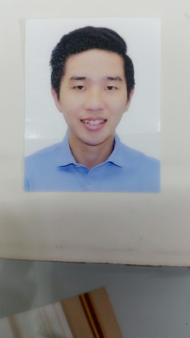JEFF ANG CHING KAI

Chai Chee Drive Block 56 #12-152, S460056

+65 97212948

Ang_chingkai@hotmail.com

# CAREER OBJECTIVE

To secure a career in working for a company where a solid work ethic, energy, and innovative strategies. Furthermore, hoping to learn acquire new skills and knowledge.

# EDUCATION/Certification HISTORY

July 2013 – Aug 2015 **Royal Melbourne Institute of Technology**, Australia

Bachelor of Business in Accountancy

Jan 2007 – Nov 2010 **Temasek Polytechnic**, Singapore

Diploma in Media & Communication Technology

# WORK EXPERIENCE

Sept 2015 – Current **MOORE STEPHENS LLP**, Singapore

Audit Associate

External Audit:

* Planned and conduct full scope audit on listed and non-listed companies such as Ship Management, Insurance and Manufacturing sector
* Conducted risk assessment at the beginning of audit project
* Performed internal control assessment such as business process and generate comprehensive audit report with detailed analytics
* Budgeted for audit hours and responsible for managing staff allocation
* Assisted managers in preparing the agenda for both internal and external meetings or discussions
* Conducted client interviews and led internal meetings to facilitate effective and efficient audit planning and execution
* Preparing consolidation audit report
* Overseas assignments – China & Penang

Corporate Finance –Due Diligence:

* Perform background checks and reviews in strict accordance with regulatory
* Work collaboratively with relevant team and stakeholders to achieve set objective and resolved any issues during daily task
* Collection, review and documentation of relevant due diligence information i.e. valuation analysis

Jul 2014 – Feb 2015 Certis Cisco Pte Ltd, Singapore

Armed Auxiliary Police Officer

* Responsible of securing clients property safely to locations
* Provide security support in major events

Apr 2013 – May 2014 Allport Cargo Services, Singapore

Account assistant

* Assist with general administrations & month end closing
* Account reconciliation, raising account payable invoices and preparing payments to suppliers
* Provide direct support to finance director and finance manager

# SKILLS

Computer Skills:

Communication and presentation: Microsoft word and Microsoft excel (ie. Pivot table)

Graphic and video editing: 3Ds max (Animate and video editing)

Accounting software: ERP & Flex Accounting software

# KEY COMPETENCIES

Works well under pressure, able to meet deadlines

Good communication skills with clients

Knowledge in forex markets

# INTERESTS AND ACTIVITIES

Domestic forex trading

Reading – Financial market, stocks and currencies